Project Data Flow Diagram

(Sample data flow image)

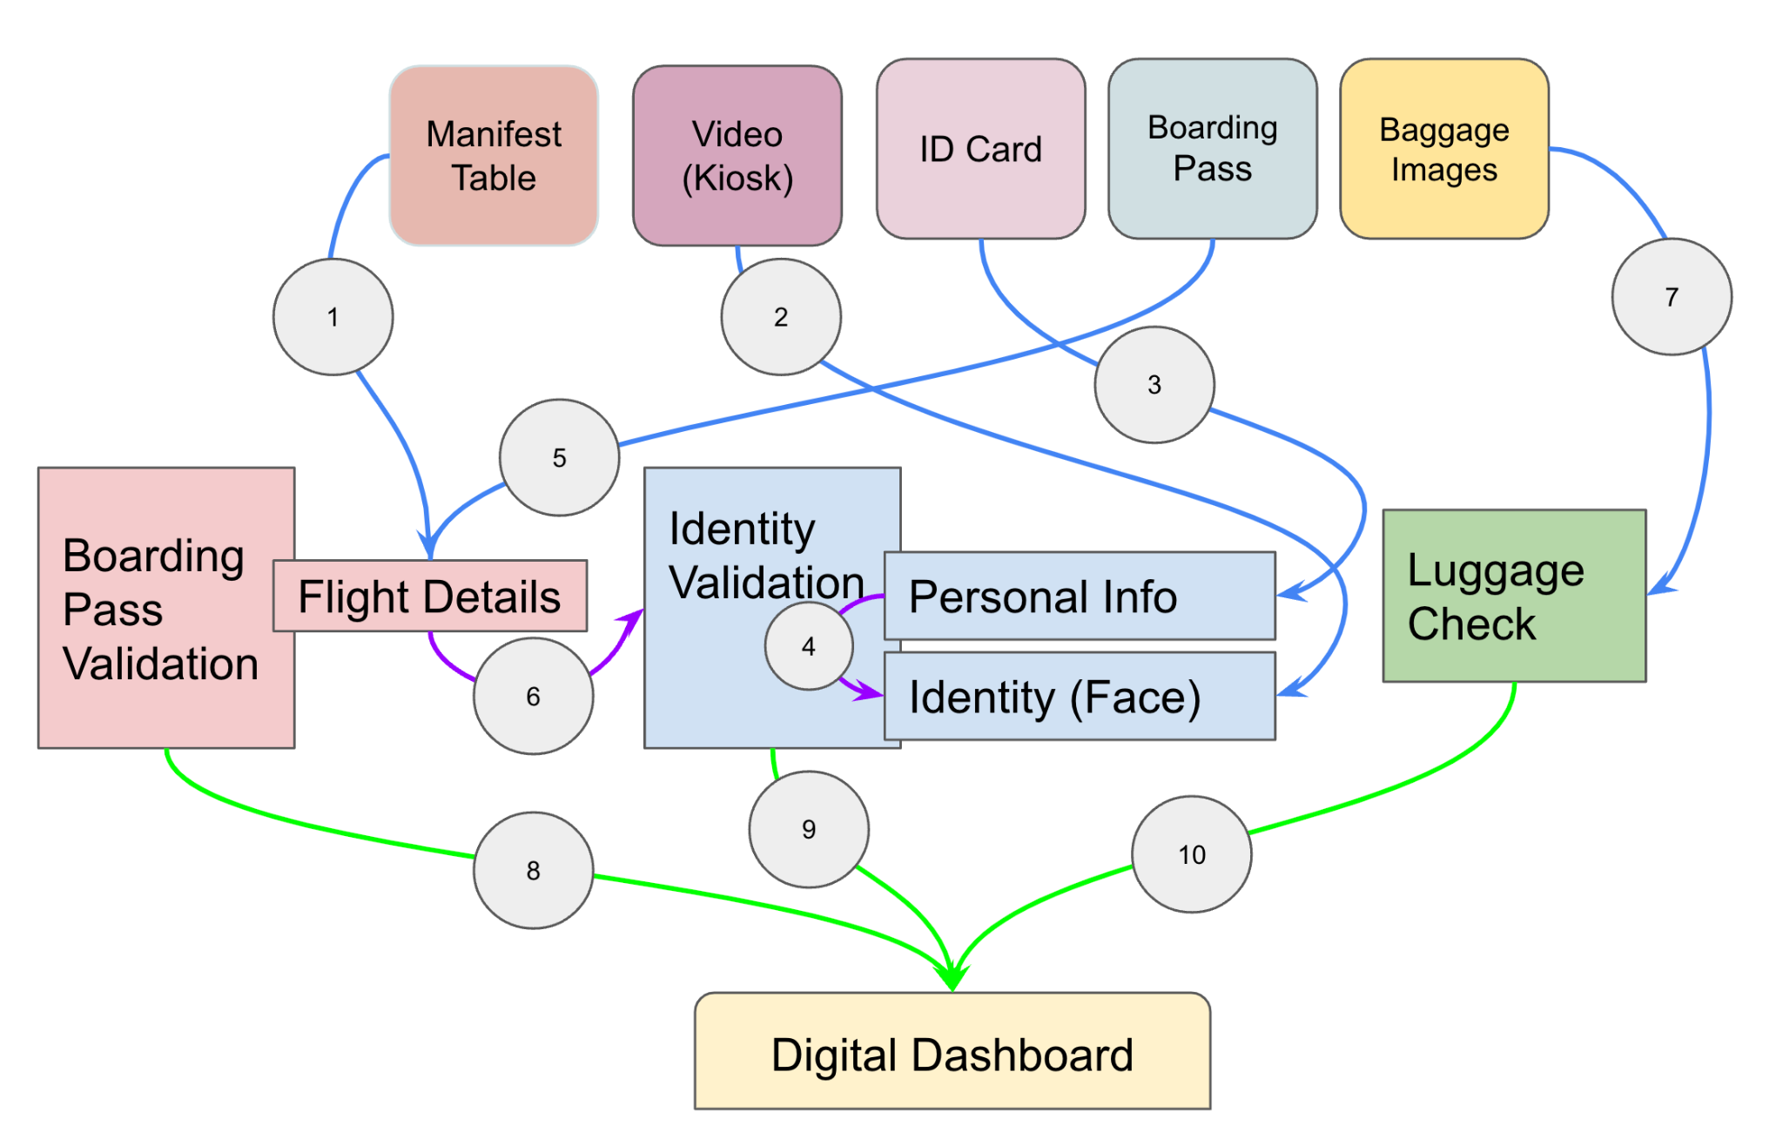

**Explaining Data Flow as shown in the above image:**

1. Manifest table has list of all passengers in the plane
2. Video input is used to identify the face
3. ID card info is used to setup the passenger identity
4. Face from ID is matched with face from video in “Identity Validation”
5. Boarding pass data is matched with the flight details
6. Flight details are matched with Identity validation for personal info checking
7. Baggage data is used for language check
8. Boarding pass validation is done
9. Identity Validation is done
10. Baggage check validation is done

**How to create the Data Flow Diagram:**

* Collect all the input components available in your project
* Collect all the data processing component which collect data from the input components and then process it
* Collect all the outputs your project generates
* At the top level (or at the bottom as desired) please display all of your input components
* Now in another layer please display all the processing components
* Finally laid out the output components
* Next draw proper arrows from input to your processing components as many as needed to make sure all the inputs are handled correctly by the processing components
* If there are connections between the processing components please draw them too with proper arrows
* Finally connect all the processing components which generate the final results to the output components

**Your Objective:**

* Make sure when someone looks at your data flow diagram they can understand what happens in your project and how various components are responsible for the data manipulations as well as how does data flow from input to output